**NAMUWAYA EDUCATION CENTRE**

**PRIMARY FOUR INTERGRATED SCIENCE**

**MID TERM TWO EXAMINATION 2024**

**NAME: _________________________________________________________________________**

**SCHOOL: _____________________________________________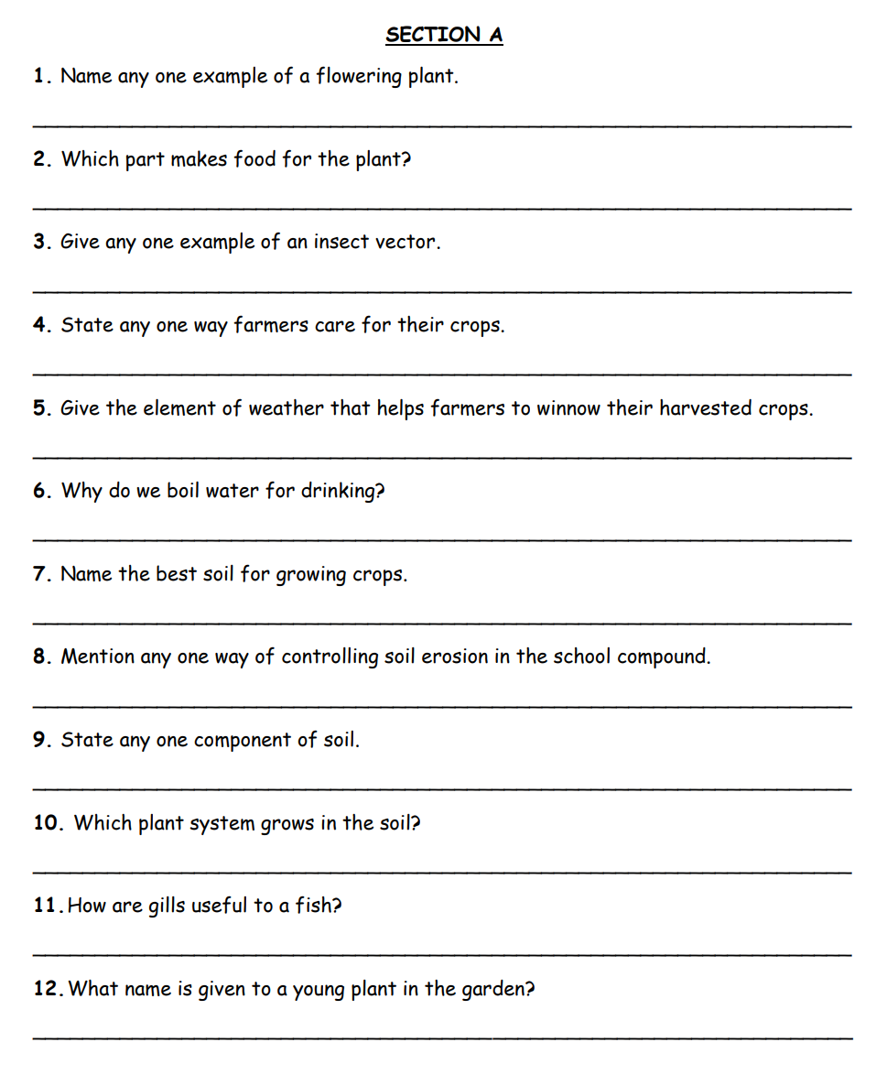___________________________**

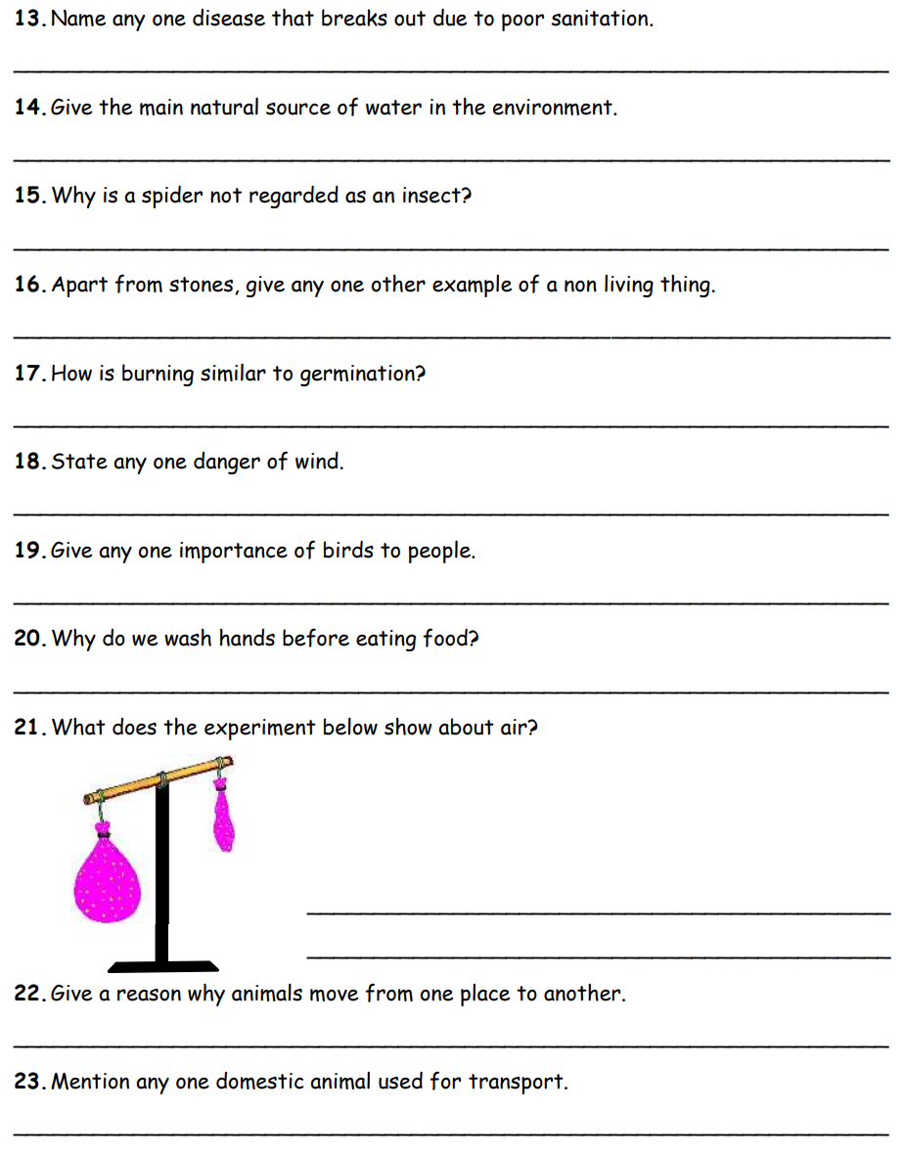

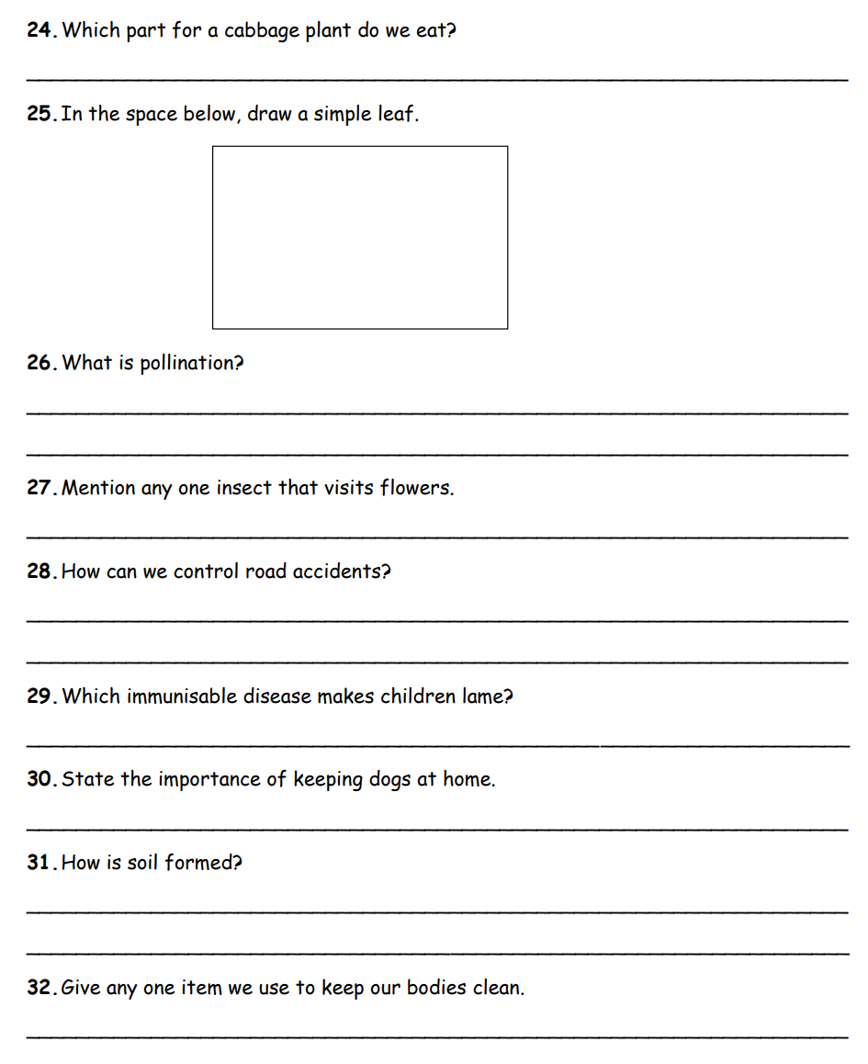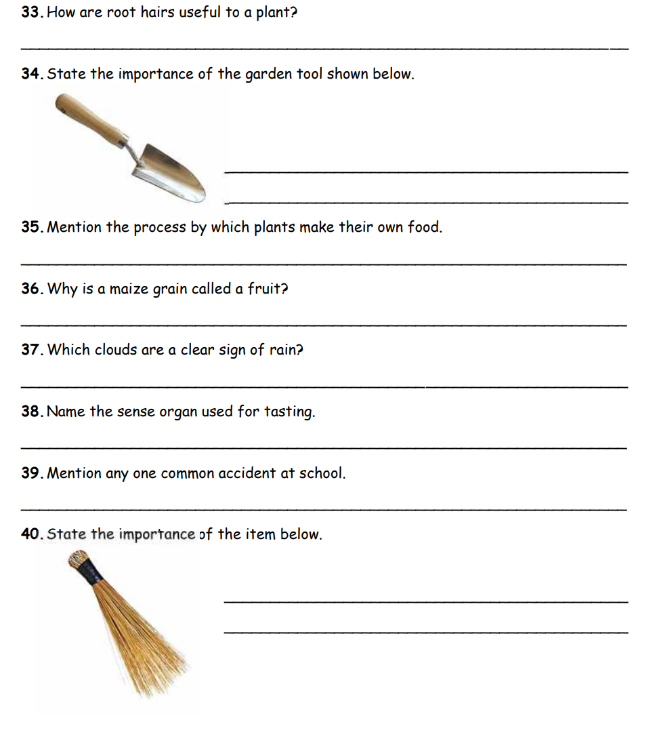

41. Define the following terms as used in our food

(a)food

___________________________________________________________________

(b)food nutrition

___________________________________________________________________

(c) balanced diet

___________________________________________________________________

(d)food contamination

___________________________________________________________________

_______________________________________________________________________

42. State any four reasons why people eat food

________________________________________________________________________

_________________________________________________________________________

________________________________________________________________________

________________________________________________________________________

43.Point out at least two examples of food stuffs rich in;

(i) animal proteins

___________________________________________________________________________________________________________________________________

(ii)plant proteins

_________________________________________________________________________________________________________________________________________________________________________

